Your Guide To Choosing Houseplants for Every Room in Your Home
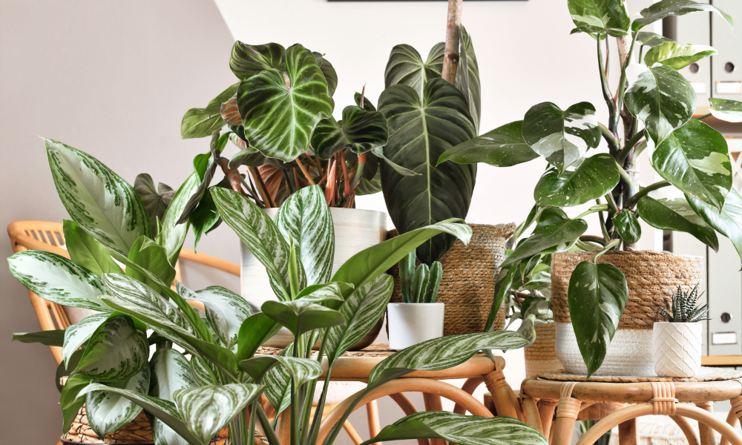
Houseplants do more than just decorate your home. They influence your mood. They improve indoor air quality. They also bring a sense of calm to everyday living. But not every plant suits every room. Lightning and humidity, temperature and layout all play their part in determining which plant will thrive where.
This guide will help you opt for the perfect plant for every room so your entire home feels naturally fresh and beautifully green.
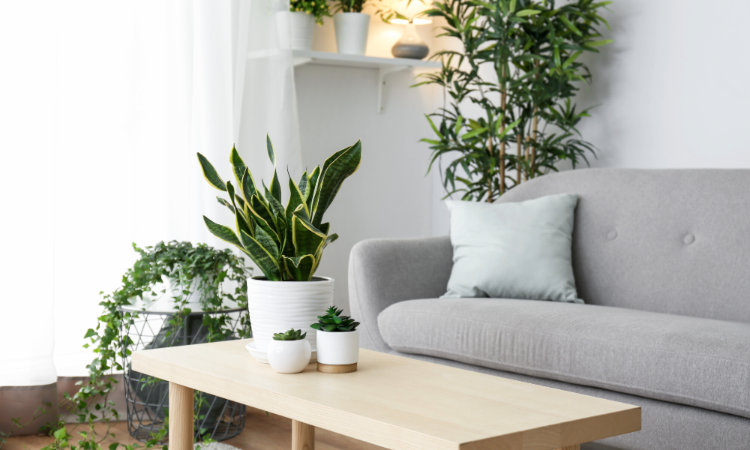

Living room: Statement Plants that Steal the Show
The living room is often the brightest and largest space in a home. It makes it perfect for statement plants.
Here are the best choices.
- Fiddle leaf figs are tall and claustral as well as bold.
- The Areca palm adds tropical vibes and soft movement.
- The rubber plant, which is modern and the glossy foliage that adds elegance.
- Monstera deliciosa, which has trendy split leaves and dramatic growth.
These planets thrive with bright and indirect sunlight. They create a centerpiece defect that instantly elevates decor.
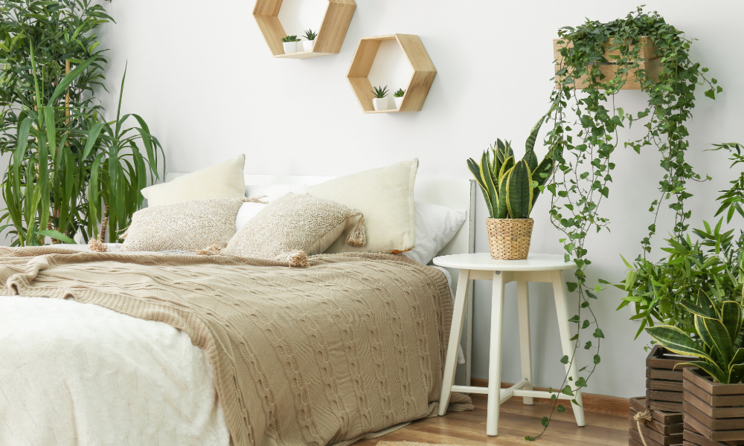

Bedroom plants: Plants that Promote Rest and Clean Air
Your bedroom should feel peaceful and fresh as well as restful. The right plants help create that environment.
Here are the top picks.
- Snake plant, which releases oxygen at night. It is an excellent air purifier.
- Peace lily, which is great for low light and improved indoor humidity.
- Lavender must be kept near a sunny window. It has a calming scent that assures you of relaxation.
- The ZZ plant is low-maintenance and perfect for darker rooms.
Water these plants sparingly and keep them dust-free for maximum benefit.
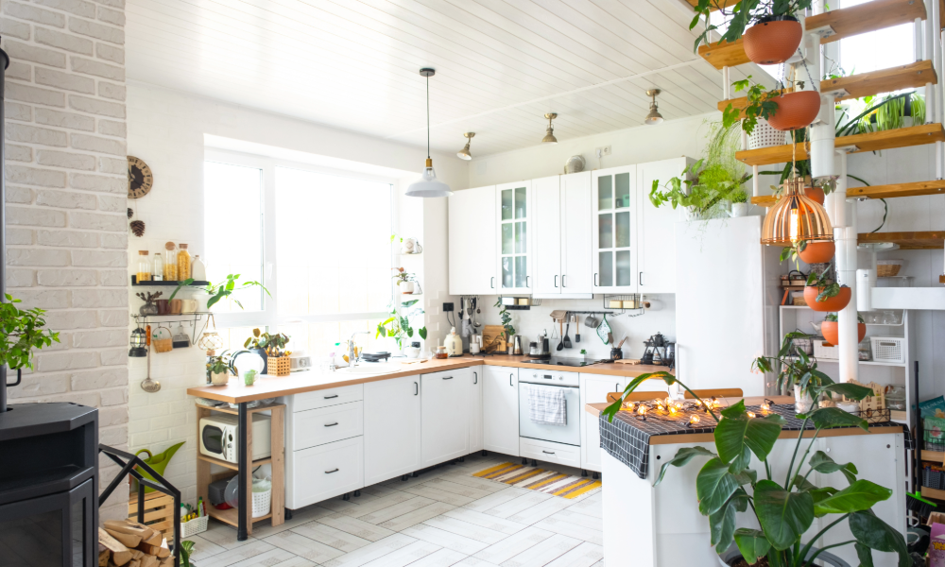

Kitchen: Hardy Plants that Love Warmth and Humidity
Kitchens have functioning temperatures and occasional steam with limited space. So, you need plants that adapt easily.
Here are some recommended houseplants for the kitchen.
- Herbs such as basil and mint, or thyme. They are fresh and useful as well as grow fats.
- Aloe vera which loves sunlight and is useful for burns.
- Spider plant, which thrives in humidity and removes toxins.
- Pothos, which requires minimal watering and grows beautifully.
Place the herbs near sunny windows and others on shelves or fridge tops.
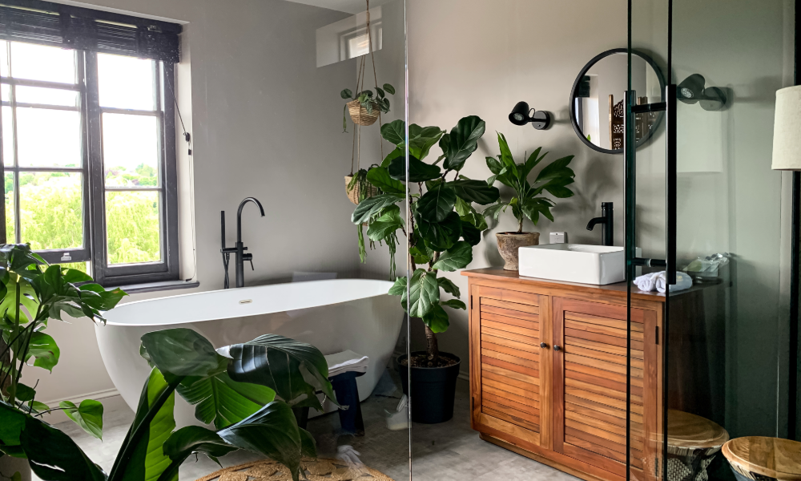

Bathroom: Moisture-Loving Plants
Bathrooms naturally have higher humidity. It makes them perfect for tropical plants.
Here are some of the best indoor plants.
- Ferns that thrive in a mixture and indirect light.
- Peace lilies, which handle humidity well.
- Lucky bamboo, which grows even in low light and survives in water.
- Philodendron is great for shelves and cabinets.
Ensure that your bathrooms get some natural light or use LED grow lights.
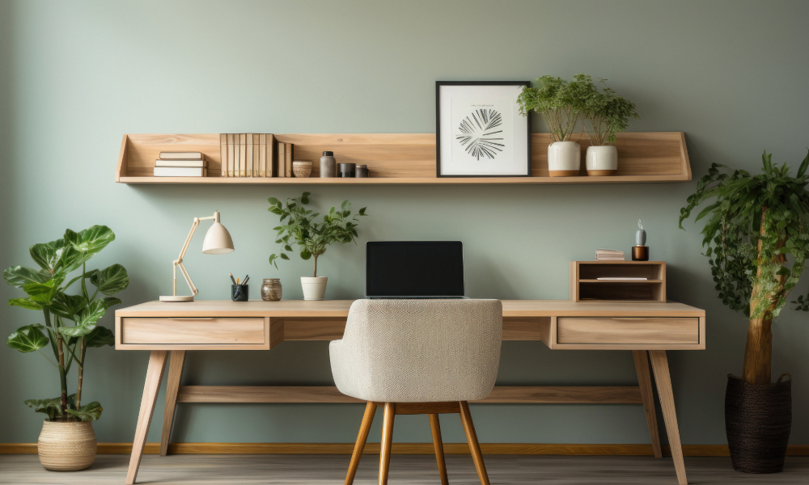

Study Room of Office Plants: Plants that Boost Focus
Plants help reduce stress and improve concentration. It makes them ideal for workspaces.
Here are some of the plants that are best for productivity.
- The Jade plant is compact and low-maintenance. It is also symbolic of preposterity.
- Succulents require minimal care. They add appeal and charm.
- Snake plant, which clears airborne toxins.
- English ivy absorbs VOCs and improves air quality.
These places brighten the space without overwhelming your desk.
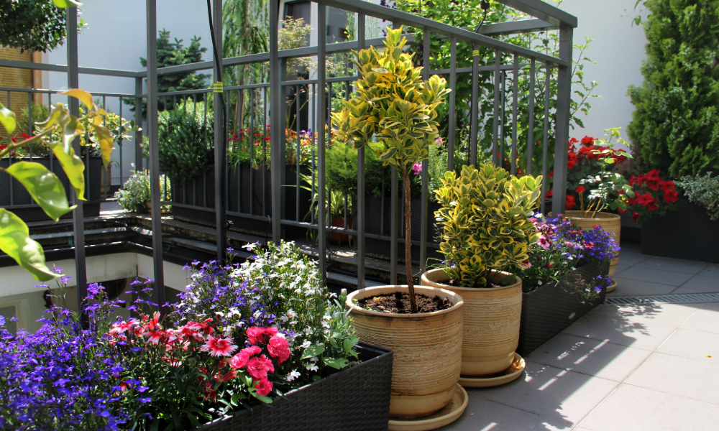

Balcony: Sun-Loving and Outdoor-Tolerant
Balconies provide the best sunlight. So, choose indoor plants accidentally.
Here are some plants that are a perfect balcony.
- Bougainvillea, which has bright and colorful blooms.
- Hibiscus, which loves warmth and sun.
- Succulents and cacti thrive in bright light.
- Money plant, which is great for railing or hanging pots.
Use sturdy pots that withstand wind and heat.


How to Maintain Soil Health in Container Gardening?
Healthy soil is the base of long-lasting container plants indoors, but pots lose nutrients faster than ground soil. Always loosen the top layer every 10 to 15 days to improve growing soil to maintain fertility. Add a handful of compost or vermicompost monthly to refresh microbial activity. Avoid letting water stagnate. It is because it compacts the soil and harms roots.
Suppose you notice the soil level is sinking, top dress with a mixture of cocopeat and compost. Replace at least one-third of the pool soil once a year. It keeps plants strong and pest-resistant, as well as capable of producing vibrant new growth.
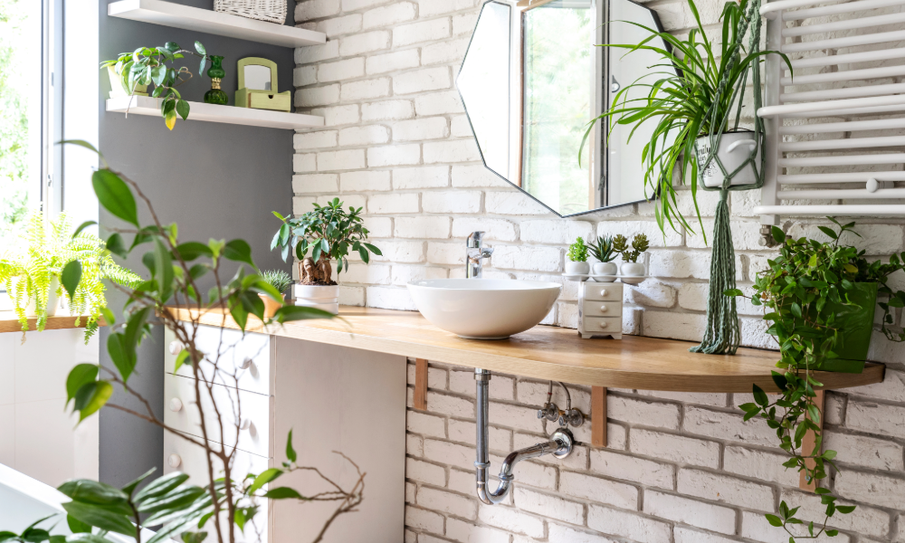

Plant Styling Tips for a Faithful Indoor Aesthetic
Indoor plant styling enhances decor and plant health. Start by grouping plants with similar care needs to simplify water management and sunlight management. Use plant stands at varying heights to create visually appealing layers. Place large floor plants in empty corners to fill space naturally. Plants turn any room into a lively, calming environment when styled thoughtfully.

Final Words
Choosing plants based on room conditions changes everything about your indoor gardening experience. When each plant gets its ideal light and humidity, along with space, your home transforms into a seamlessly thriving green sanctuary, starting small by placing one plant in each room and watching our indoor world bloom with fresh life and colour as well as beauty.

FAQs
Which houseplant is best for low light rooms?
Snake plants and ZZ plants along with Pothos thrive even in low light corners.

Which plants are suitable for bedrooms?
Peace lily and snake plant as well as lavender are the best choices as they improve sleep and reduce stress along with purifying air.

How do I choose plants for each room?
Consider light and humidity as well as temperature and space before selecting a plant for any room.

